|  |
| --- |
|  |
| Advance Development System Group Assignment |
| |  |  |  | | --- | --- | --- | | … | … | … | |



## Group Members

|  |  |
| --- | --- |
| Student Names | Student Number |
| Nkoana Hope Lerato | 202204804 |
| Mawela Mpho Precious | 202233722 |
| Khalo Ayanda Girly | 202213324 |
| Dlamini Kelebogile Sylvia | 202224253 |



## GUI + Description For Home page

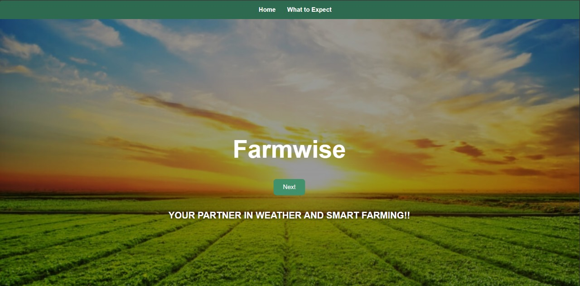

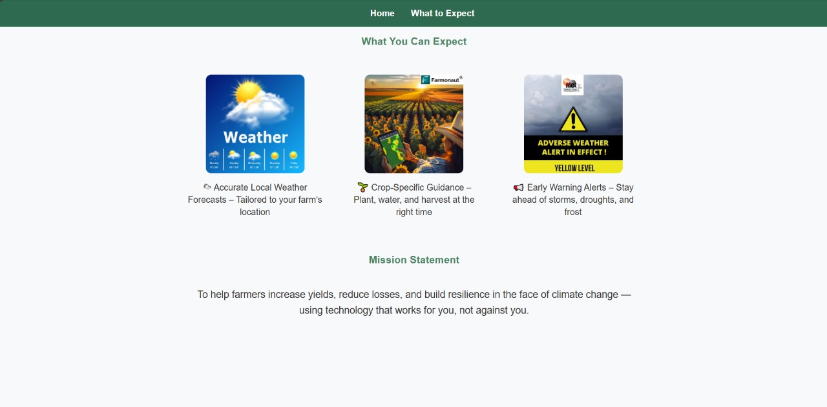

Purpose:

This is the homepage or landing page, which provides a brief overview of the system, including accurate local weather forecasts, crop-specific guidance, and early warning alerts. It also presents the mission statement. The webpage is scrollable, allowing users to move up and down to access more information.



## GUI + Description Selection page

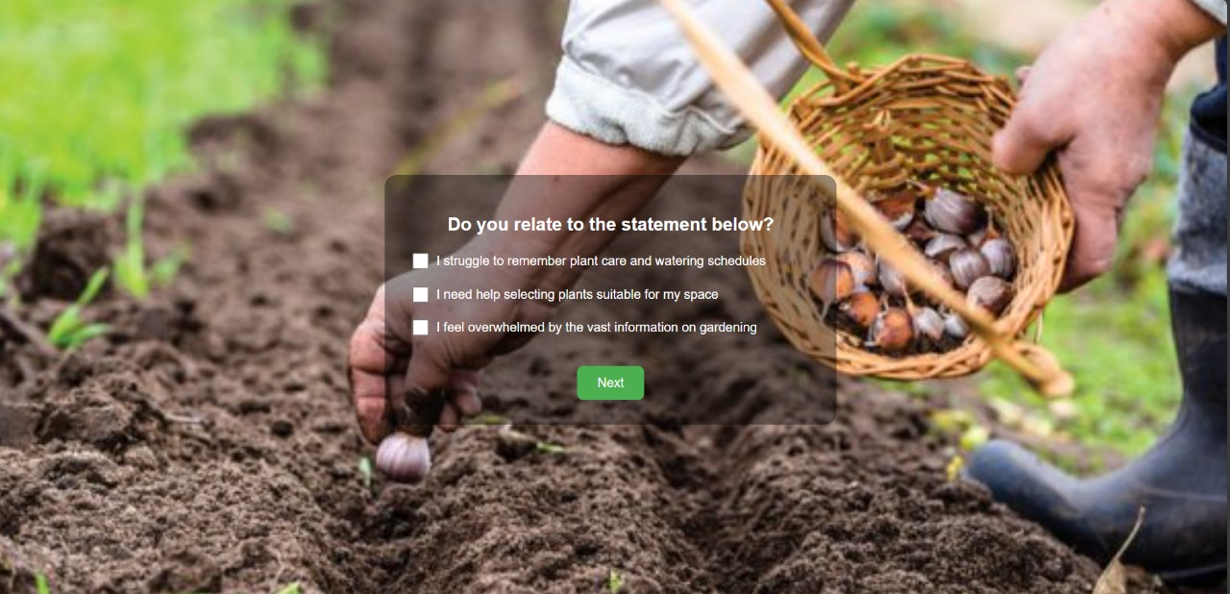

Purpose:

This is the selection page, where the user is presented with three checkboxes. They can select the statements that are most relatable to them and then proceed to the next page.



## GUI + Description Weather Analysis Dashboard

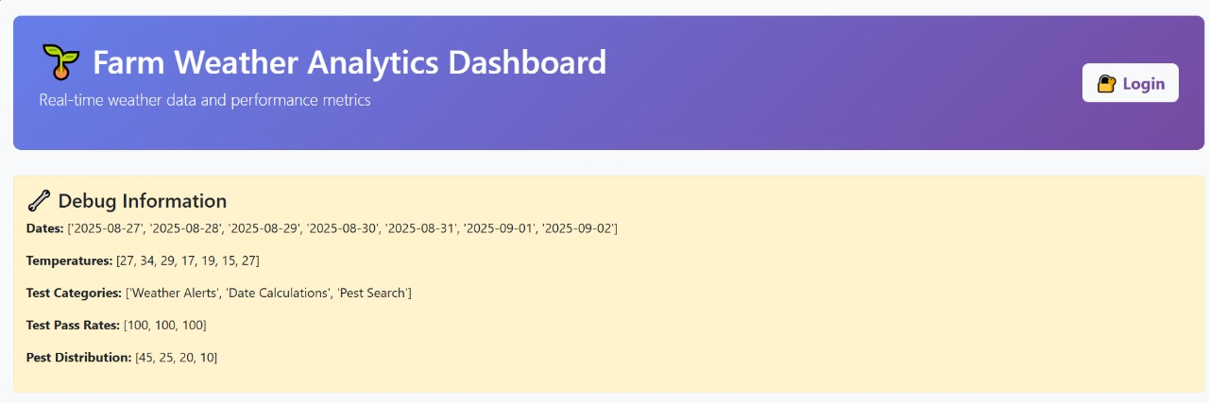

Purpose:

This is the Farm Weather Analysis Dashboard page. It provides an overview of the system and gives users insights into what the API can do through visualizations. The dashboard displays real-time weather data and performance metrics, including graphs that show 7-day weather trends, unit test performance, and pest distribution analysis.

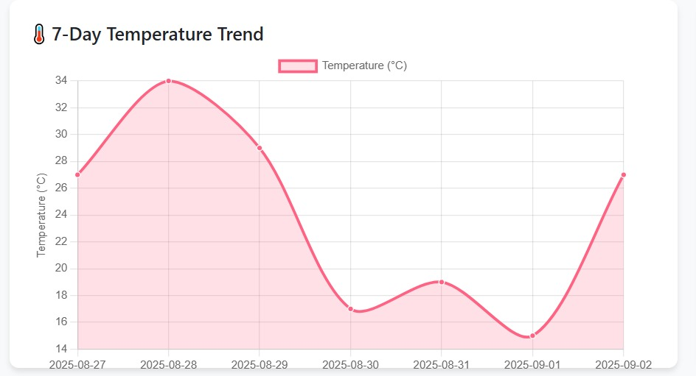

1. Temperature Trend Line Chart

Description:

This line chart visualizes the 7-day temperature pattern, providing farmers with critical insights into recent weather trends. The x-axis represents the dates, while the y-axis displays temperature values in Celsius. The smooth curve connects daily temperature points, showing the progression and variability of weather conditions over the week.

Purpose & Value:

* Frost Risk Assessment: Enables quick identification of temperature drops near or below freezing (0°C)
* Growing Condition Analysis: Helps determine optimal planting and harvesting windows based on thermal patterns
* Trend Prediction: Allows farmers to anticipate upcoming weather patterns and make proactive decisions
* Data-Driven Planning: Supports irrigation scheduling and crop protection measures based on thermal data
* Technical Insight: The chart uses a tension parameter of 0.3 to create a smoothed curve that emphasizes overall trends rather than daily fluctuations, making it easier to identify patterns crucial for agricultural planning.

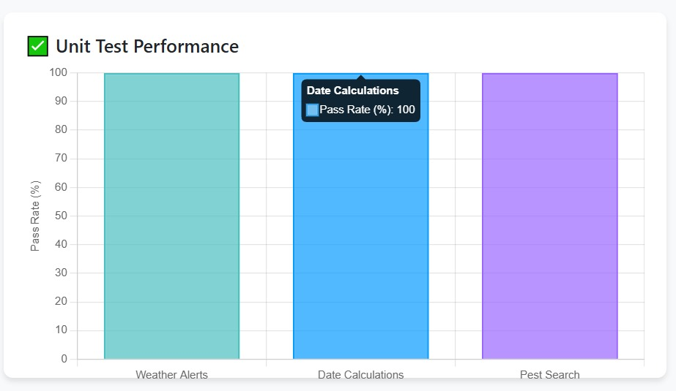

2. Unit Test Performance Bar Chart

Description:

This horizontal bar chart displays the test coverage and success rate across the application's three core modules: Weather Alerts, Date Calculations, and Pest Search. Each bar represents a module, with the length indicating the percentage of passed tests (out of 100%).

Purpose & Value:

* Quality Assurance: Demonstrates the reliability and robustness of each application component
* Performance Monitoring: Provides immediate visual feedback on system stability
* Development Tracking: Serves as a quality metric during continuous integration and deployment
* User Confidence: Shows end-users that the application has been rigorously tested and verified
* Technical Insight: The consistent 100% pass rate across all modules indicates comprehensive test coverage and successful validation of all critical functionality, ensuring dependable performance for agricultural decision-making.

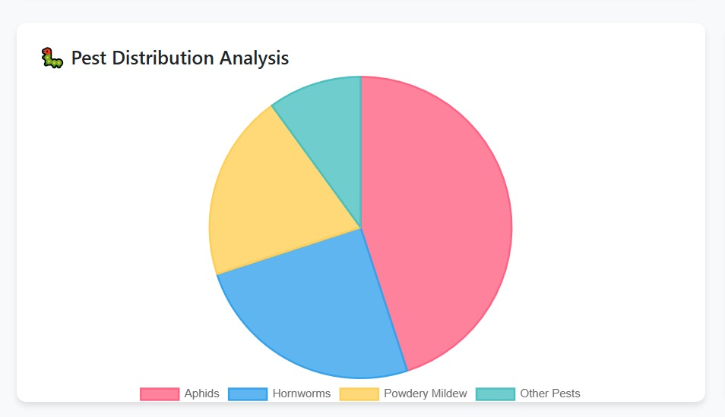

3. Pest Distribution Pie Chart

Description:

This pie chart illustrates the relative frequency of different pest types encountered in the agricultural database. Each colored segment represents a pest category, with the size proportional to its occurrence percentage. The chart uses a clear color scheme: red for Aphids, blue for Hornworms, yellow for Powdery Mildew, and teal for other pests.

Purpose & Value:

* Risk Prioritization: Helps farmers identify which pests require immediate attention and resources
* Prevention Planning: Guides the development of targeted pest management strategies
* Resource Allocation: Assists in determining the appropriate quantity and type of treatments needed
* Seasonal Awareness: Provides awareness of common pests during different growing seasons
* Technical Insight: The chart reveals that Aphids constitute nearly half (45%) of all pest occurrences, indicating they should be the primary focus of integrated pest management programs, followed by Hornworms (25%) and Powdery Mildew (20%).

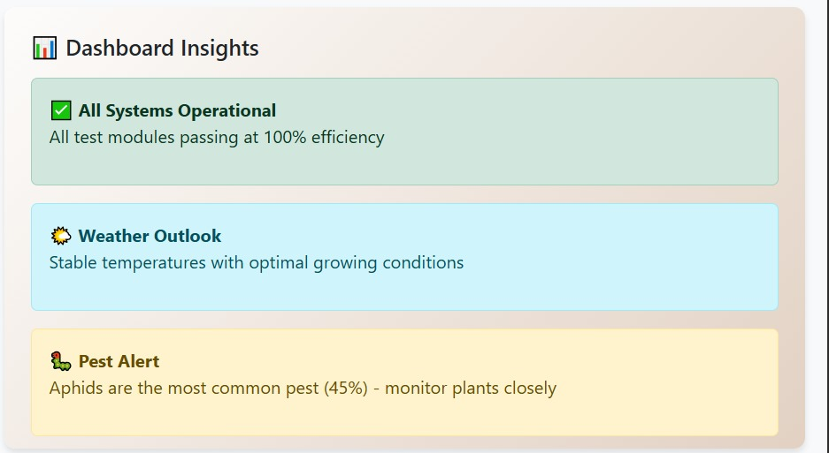

4. Dashboard Insights Panel

Description:

This informational panel provides contextual analysis and actionable recommendations based on the chart data. It features color-coded alert boxes (green for positive status, blue for information, amber for warnings) that translate raw data into practical farming guidance.

Purpose & Value:

* Decision Support: Converts complex data into straightforward, actionable advice
* Rapid Assessment: Allows quick scanning of critical information without interpreting charts
* Risk Communication: Clearly communicates urgent issues requiring immediate attention
* Educational Value: Helps farmers understand the implications of the data presented
* Technical Insight: The panel serves as an expert system that bridges the gap between data visualization and practical agricultural knowledge, ensuring that farmers can make informed decisions even without technical expertise in data analysis.



## GUI + Description For Signup and login

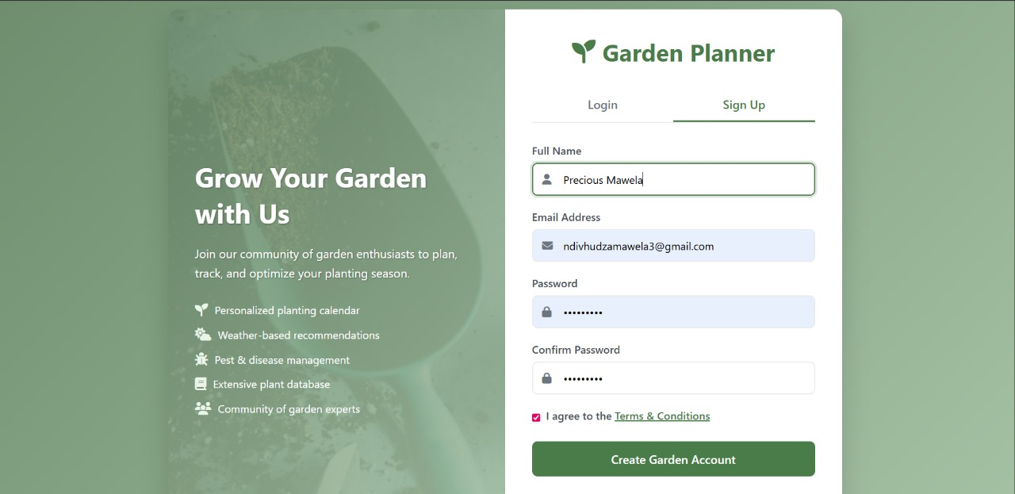

**Sign Up Page**

The **Sign Up page** allows new users to create an account to access the system’s features. Users are required to provide essential information such as:

* **Full Name**
* **Email Address**
* **Password** (with confirmation for security)

Once the user submits the form:

1. The system validates the input (e.g., checks that the email is unique and the password meets security requirements).
2. If validation passes, the user’s information is securely stored in the database.
3. A confirmation email may be sent to verify the account.
4. Upon successful registration, the user can proceed to log in and access the platform.

**Purpose:**

The sign-up process ensures that each user has a personalized account for saving preferences, tracking crops, and receiving tailored alerts and advice.



**Login Page**

The **Login page** allows registered users to securely access their accounts. Users enter:

* **Email Address**
* **Password**

The system performs authentication by:

1. Verifying that the entered credentials match a registered account in the database.
2. Allowing access if the credentials are correct.
3. Displaying an error message if the email or password is incorrect, with an option to reset the password.

**Purpose:** The login process ensures that sensitive data, such as farm locations, crop choices, and garden journal entries, remain secure and accessible only to authorized users.



## GUI + Description For Farm Weather Dashboard

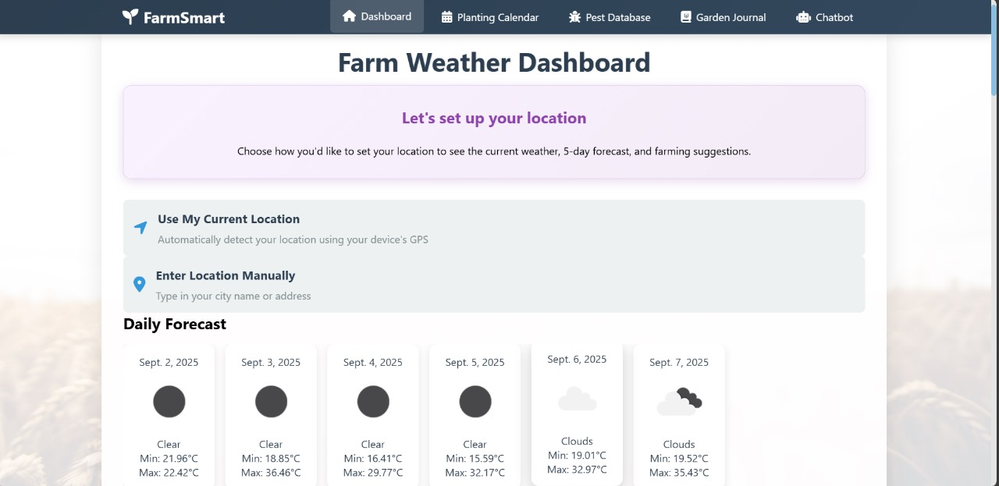

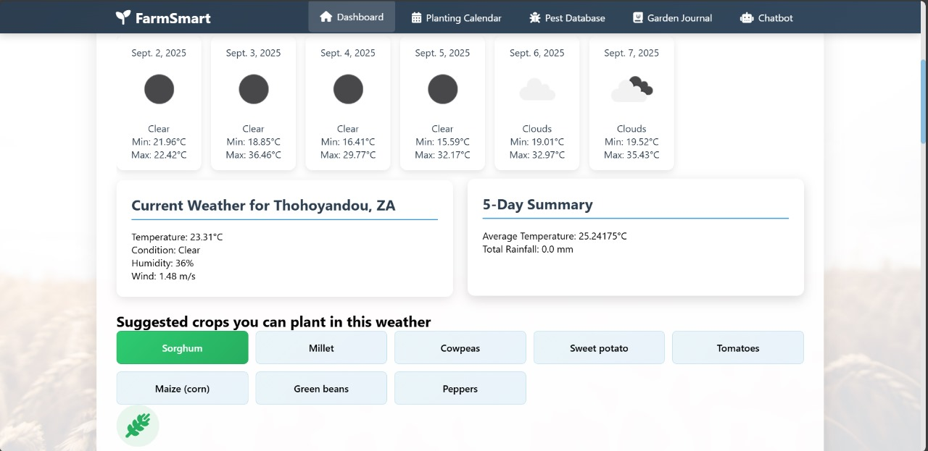

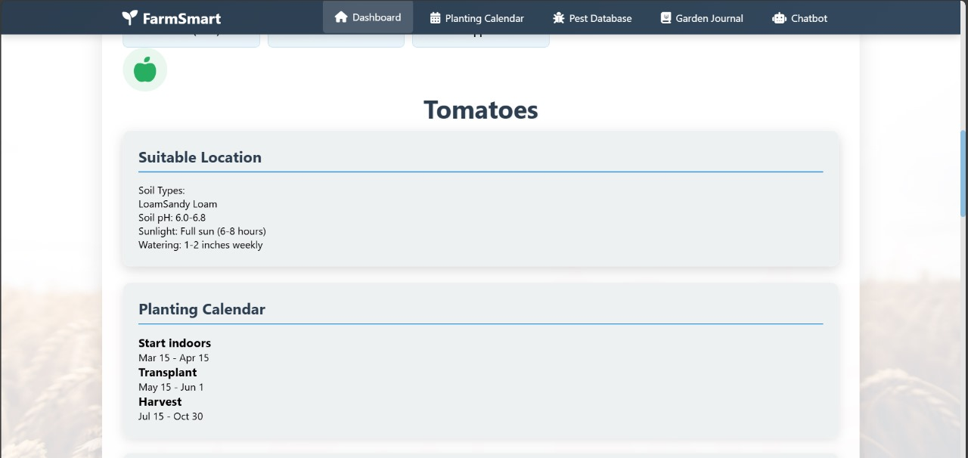

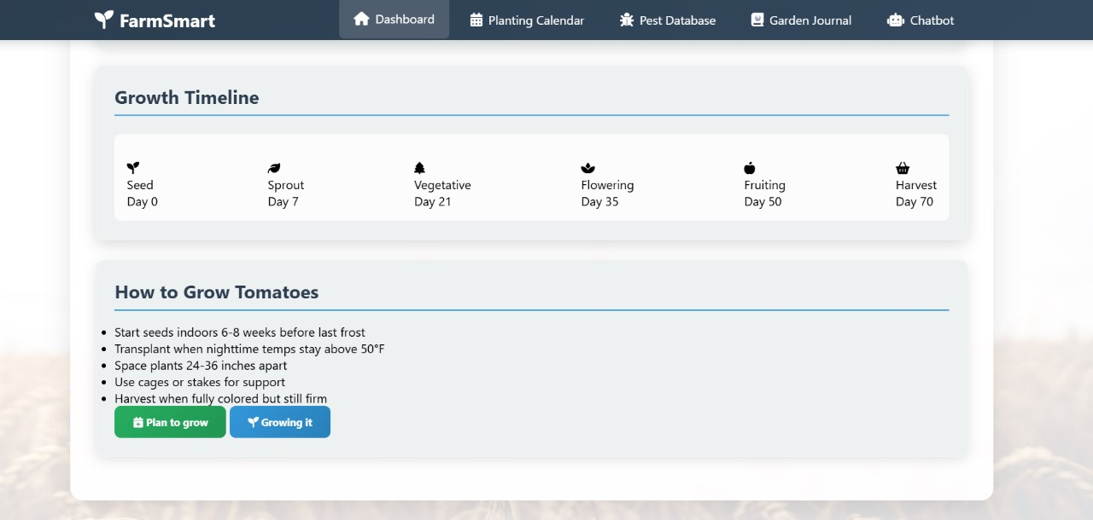

**Farm Weather Dashboard Page**

The **Farm Weather Dashboard** allows users to access personalized weather-based crop recommendations. Users can either manually enter their farm location or use the **“Use My Current Location”** button to automatically detect their location.

Once the location is set:

1. The dashboard displays the **daily weather forecast** for the next six days.
2. Based on the forecast, the system suggests **crops that grow best under the predicted weather conditions**.
3. When a user selects a crop of interest:
   * The **soil type** for their location is displayed.
   * **Soil pH** and recommended **watering methods** for the selected crop are provided.
   * A **growth timeline** is shown, detailing stages from **seed germination** to **sprouting, vegetative, flowering, fruiting, and harvest**.
   * **Farming tips and best practices** for growing the crop successfully are provided.

**Purpose:** The Farm Weather Dashboard enables farmers to make informed decisions about crop selection, planting schedules, and crop care based on local weather and soil conditions, helping to maximize yield and reduce losses due to climate variability.



## GUI + Description For Smart Planting Calendar

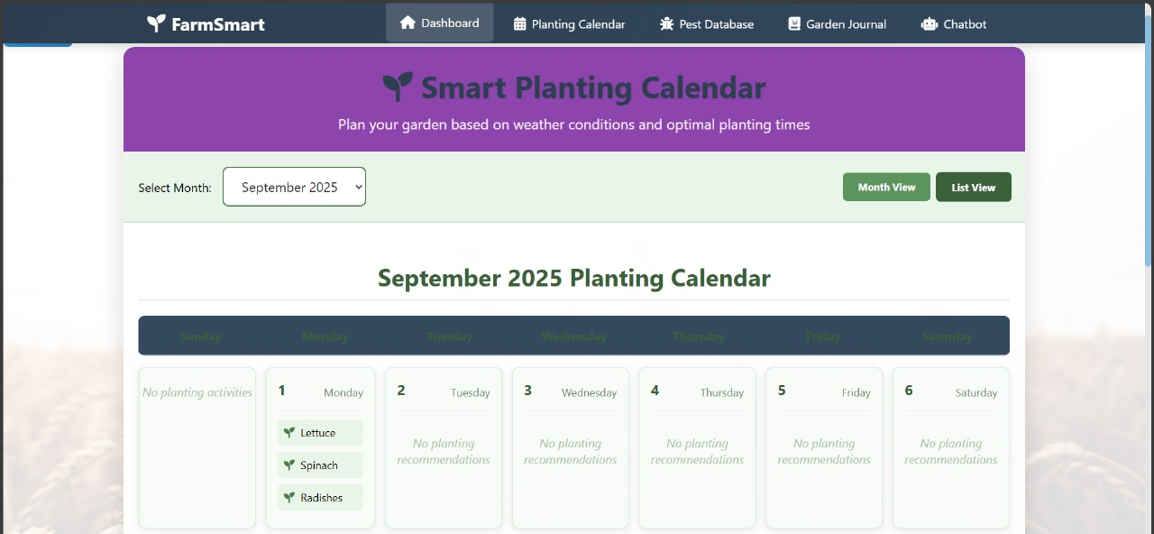

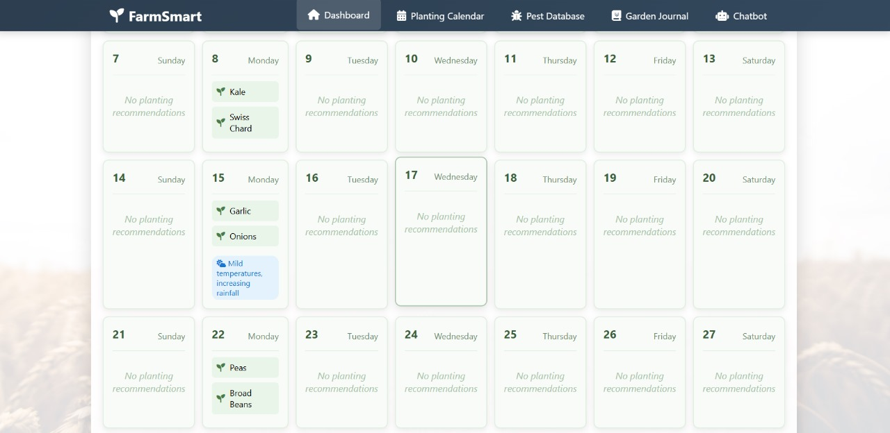

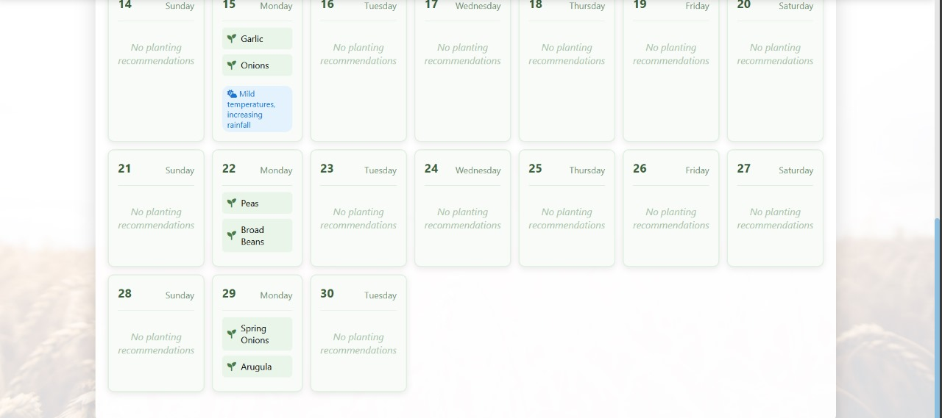

**Smart Planting Calendar Page**

The **Smart Planting Calendar** helps farmers plan their sowing and harvesting activities based on local weather conditions. Users can select a specific **month**, and the calendar displays all the days within that month.

Once a month is selected:

1. The system highlights **which days are optimal for planting specific crops**.
2. It provides information on **expected temperature conditions**, such as days with mild temperatures suitable for planting.
3. Users can use this guidance to **schedule planting activities** to maximize crop growth and minimize risks associated with adverse weather.

**Purpose:** The Smart Planting Calendar allows farmers to plan effectively, ensuring that crops are planted under favorable weather conditions, which improves yield and reduces losses due to climate variability.



## GUI + Description For Advanced Pest Disease Database

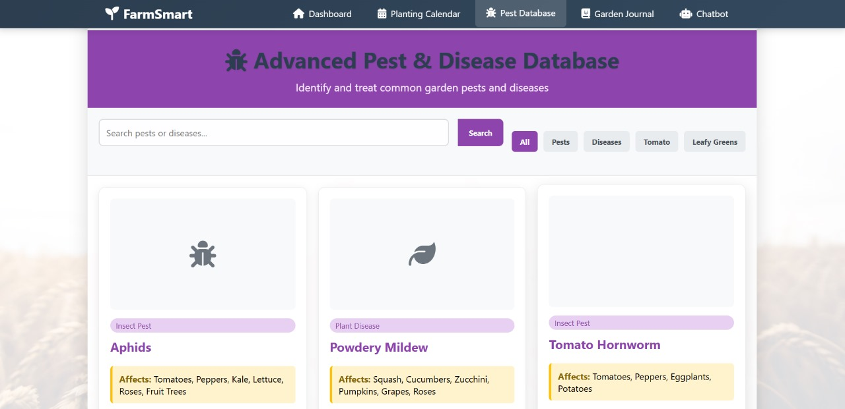

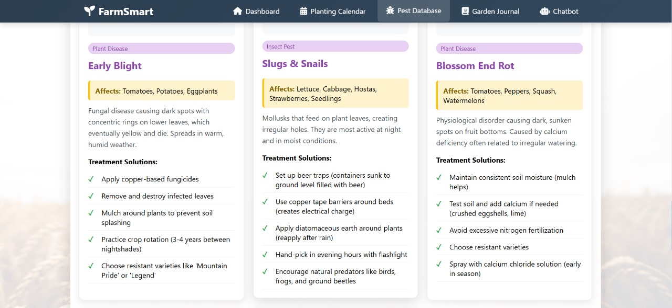

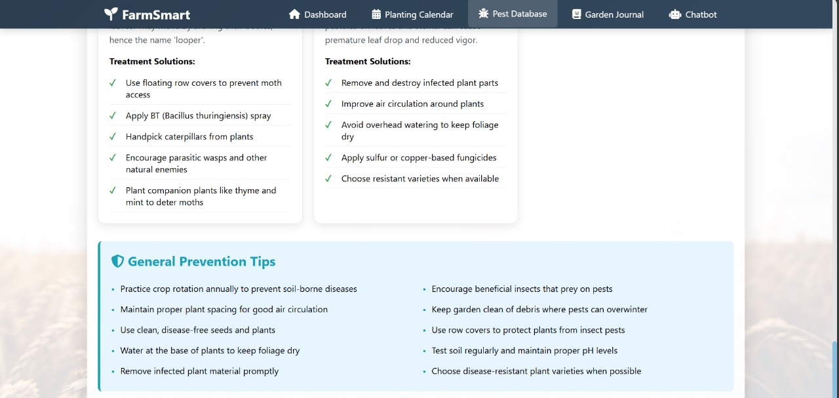

**Advanced Pest and Disease Database Page**

The **Advanced Pest and Disease Database** provides farmers with detailed information on pests and diseases that may affect their crops. Users can:

1. **Search for specific pests** and learn how to prevent or control them to protect their garden or farm.
2. **Search for plant diseases** and identify which crops are susceptible, along with recommended prevention and treatment methods.

**Purpose:** This page empowers farmers to proactively manage pest and disease threats, minimizing crop losses and ensuring healthy growth through timely and accurate guidance.



## GUI + Description For Garden Journal

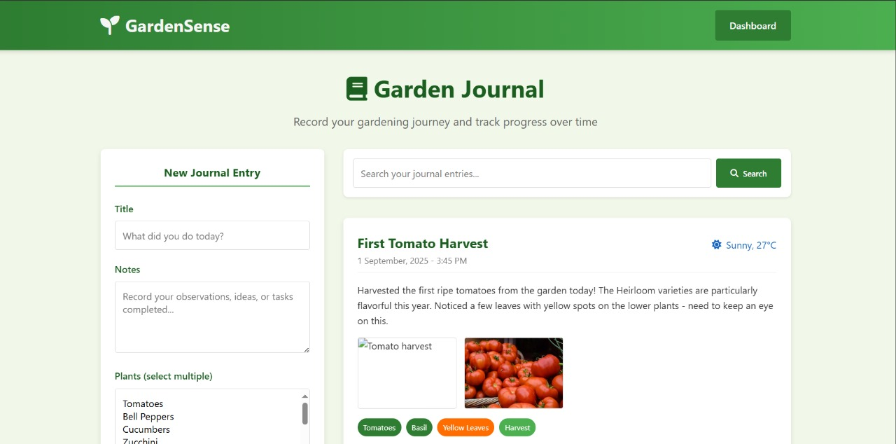

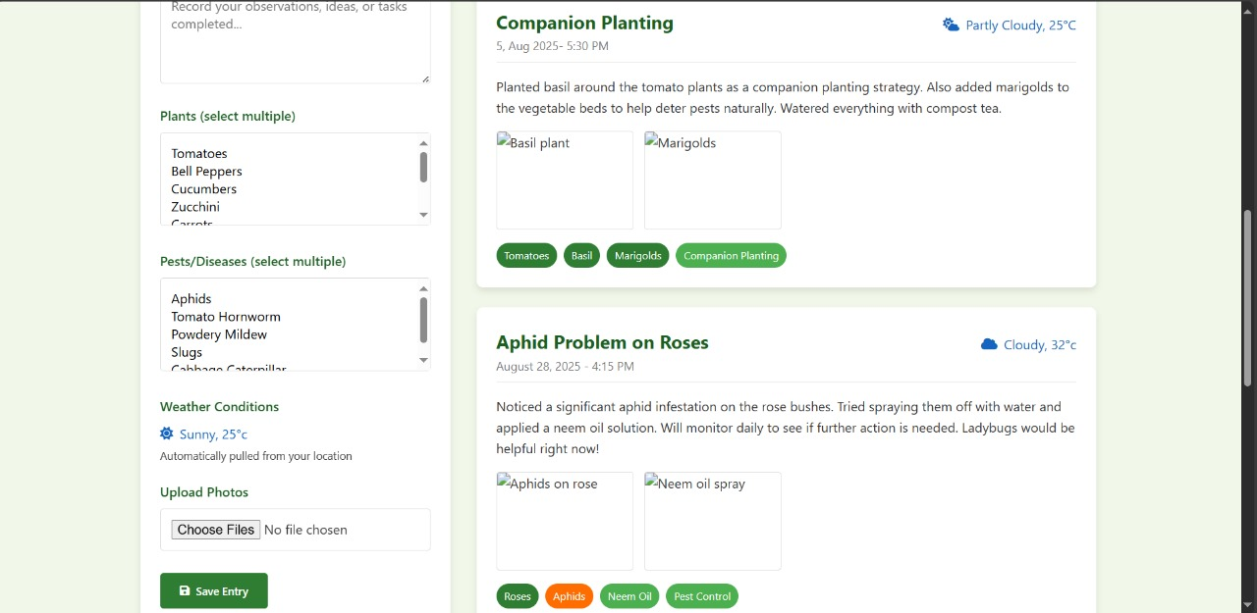

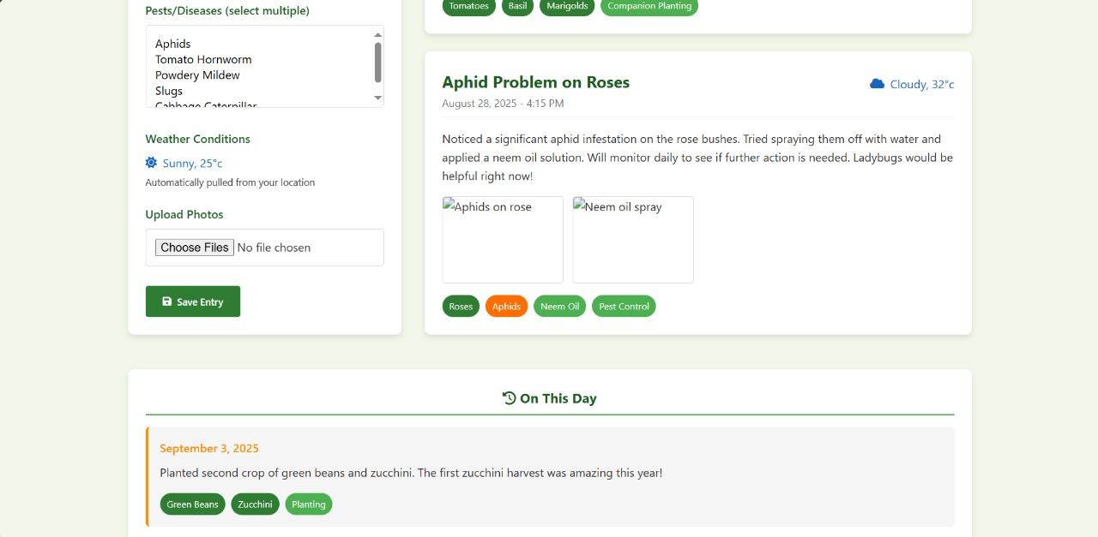

**Garden Journal Page**

The **Garden Journal** allows users to record their gardening or farming journey and track progress over time. Users can:

1. **Write about their experiences**, documenting challenges, successes, and observations.
2. **Post pictures** of their crops, garden, or farm to visually track growth and progress.
3. **Share entries with other users**, fostering a sense of community and encouraging knowledge exchange among farmers.

**Purpose:** The Garden Journal helps farmers reflect on their practices, monitor crop development, and engage with a community of peers for support and advice, promoting collaborative learning and shared problem-solving.



## GUI + Description For AI Chatbot

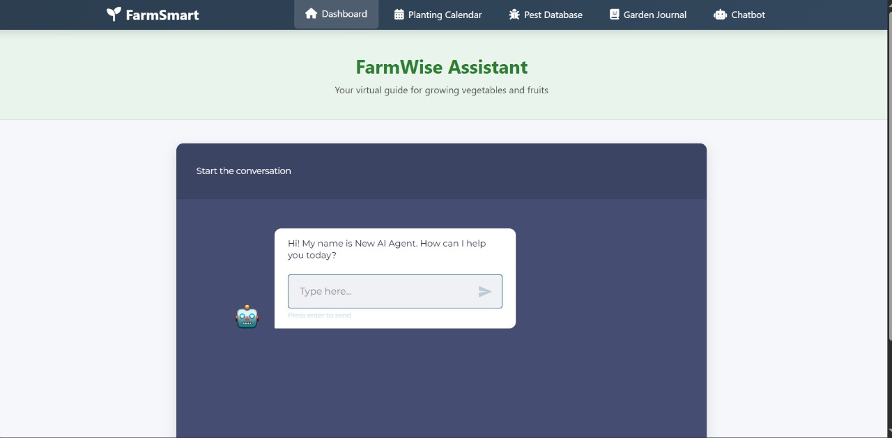

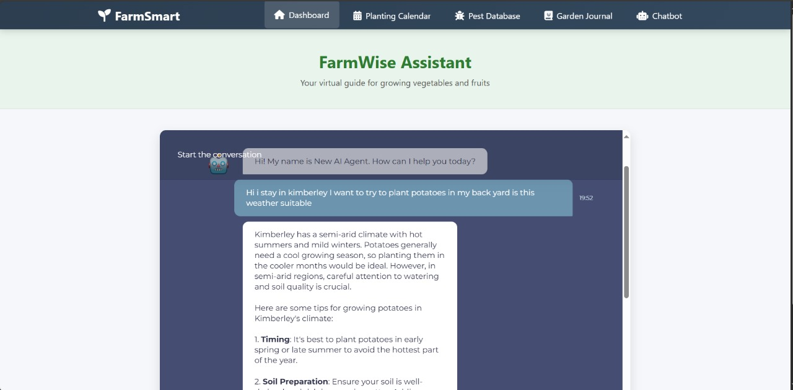

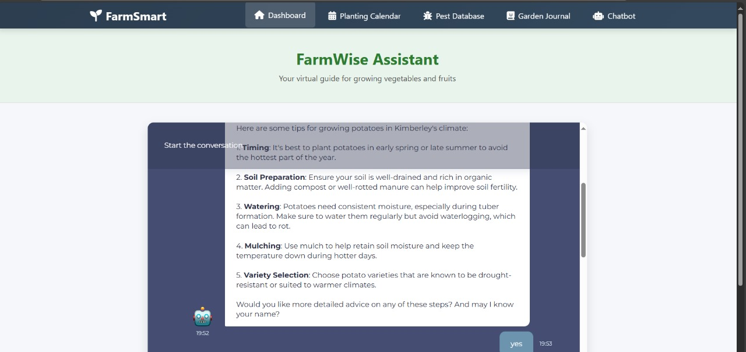

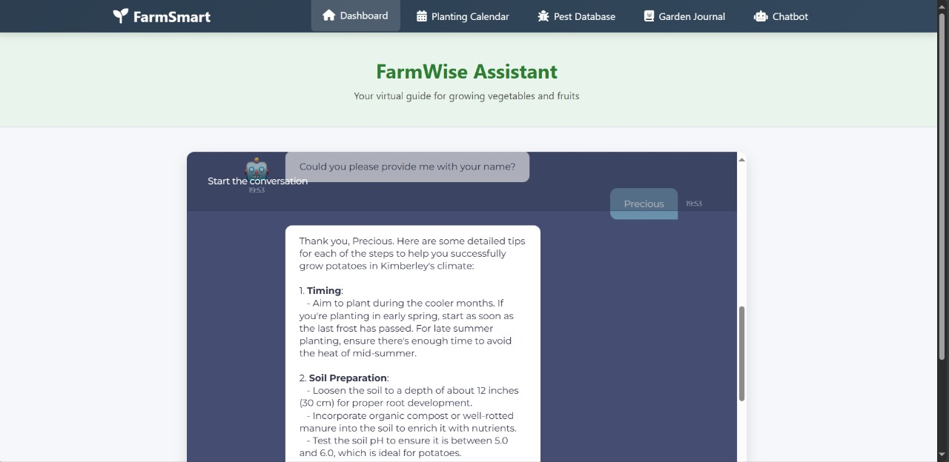

**Farmwise Assistant (AI Chatbot) Page**

The **Farmwise Assistant** is an AI-powered chatbot designed to provide personalized guidance to farmers. Users can:

1. **Ask questions related to planting, crop care, pest control, and weather-based farming advice**.
2. **Personalize the chatbot**, including having it address the user by name for a more interactive experience.
3. **Receive instant, intelligent responses** based on real-time data and best agricultural practices.

**Purpose:** The Farmwise Assistant enhances user support by offering immediate, tailored advice, helping farmers make informed decisions, solve problems quickly, and improve overall farm management.